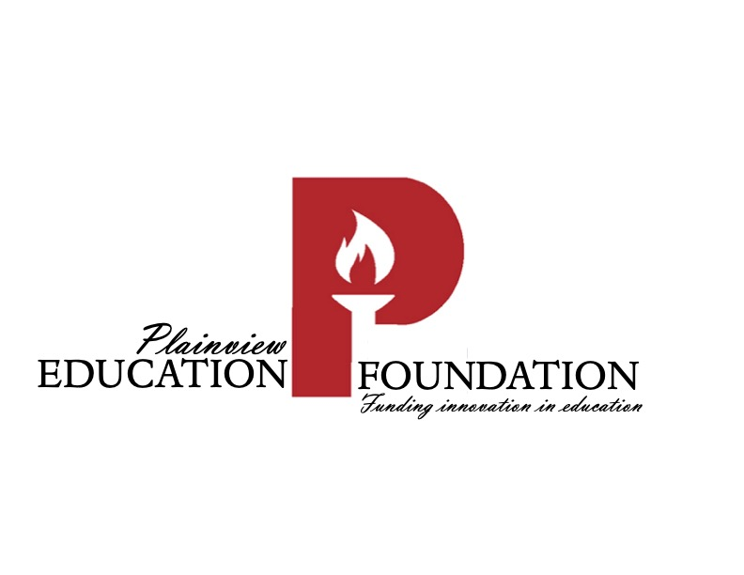

Scholarship Application Timeline

Due Date April 30, 2023

Notification of Winners Plainview Education Foundation will notify recipients early May

Payment Sent to College with enrollment verification July 2023

Payment Sent to Student with enrollment verification July 2023

